Cloud watch, Cloud trail Task
1. Enable CloudTrail monitoring and store the events in S3 and CloudWatch log events
To create a new cloud trail, click on create trail at the top

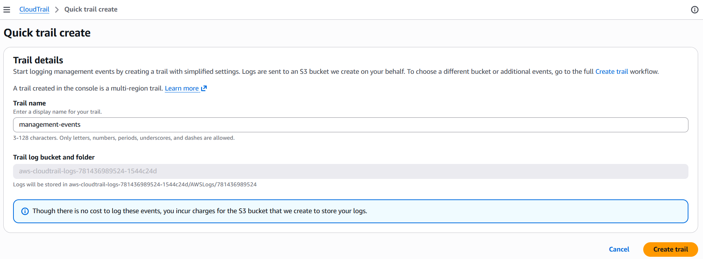
Enter the details
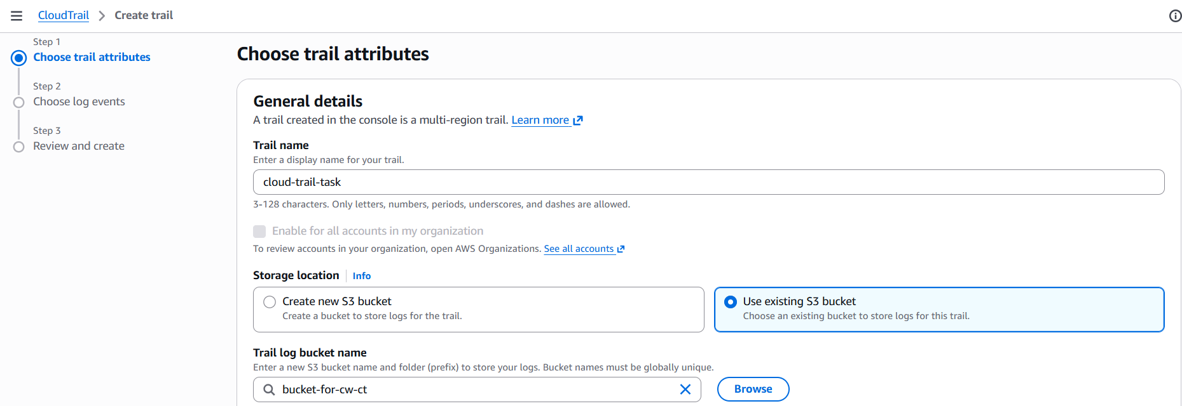
I have existing bucket, so I just attached it
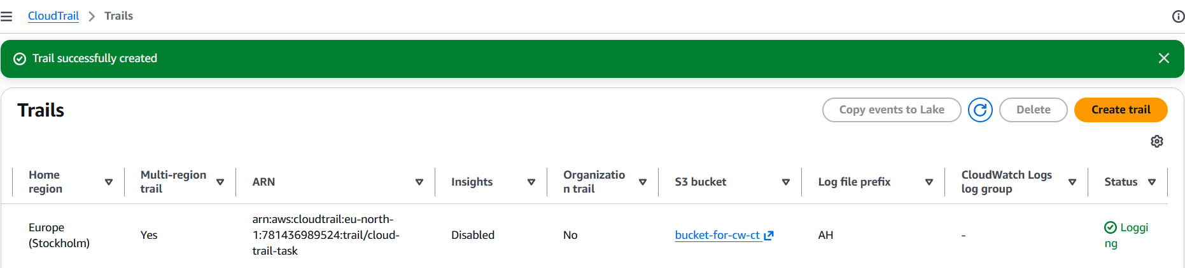
Here, I have enabled the cloudwatch logs
And also created a new IAM role
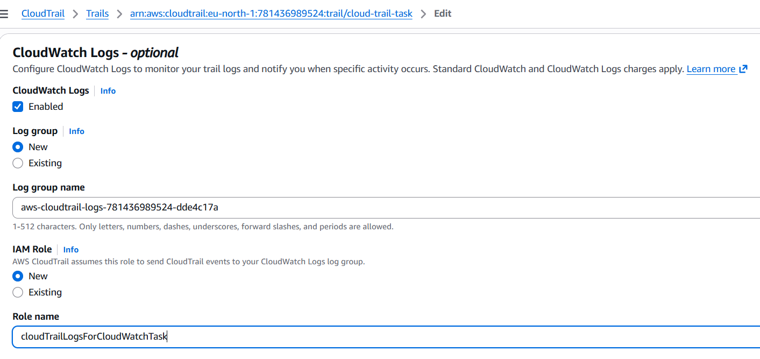
Below you can see the logs are being updated inside the bucket
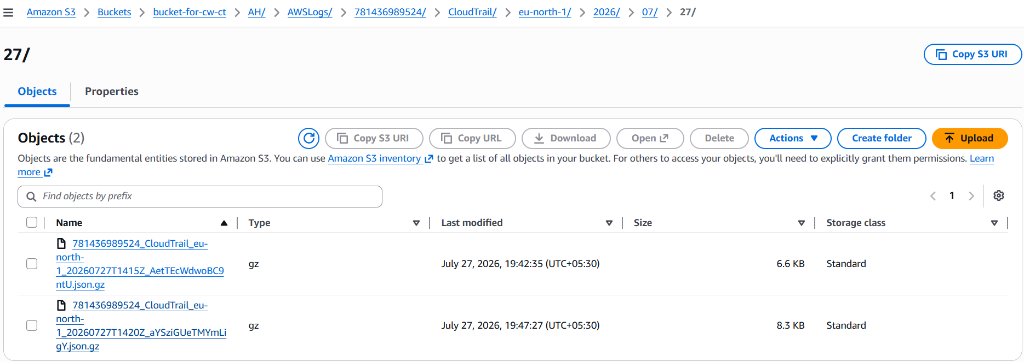
And in the cloud watch as well
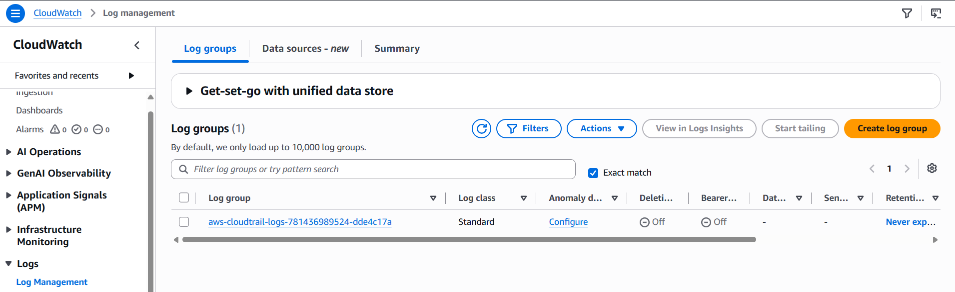

2. Enable SNS for CloudTrail to send alerts via email
To send email alerts for CloudTrail events using Amazon SNS, you can configure SNS topic directly through CloudTrail for log delivery notifications
Create a new SNS topic
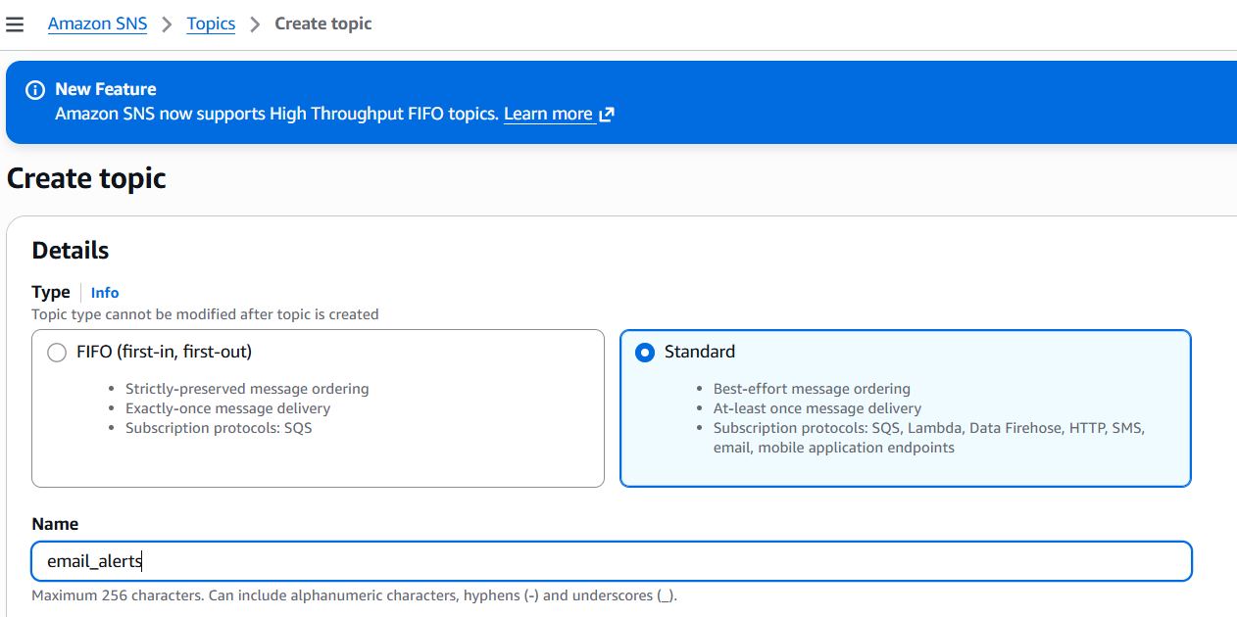
And for that sns, create the subscription by giving the protocol and endpoint
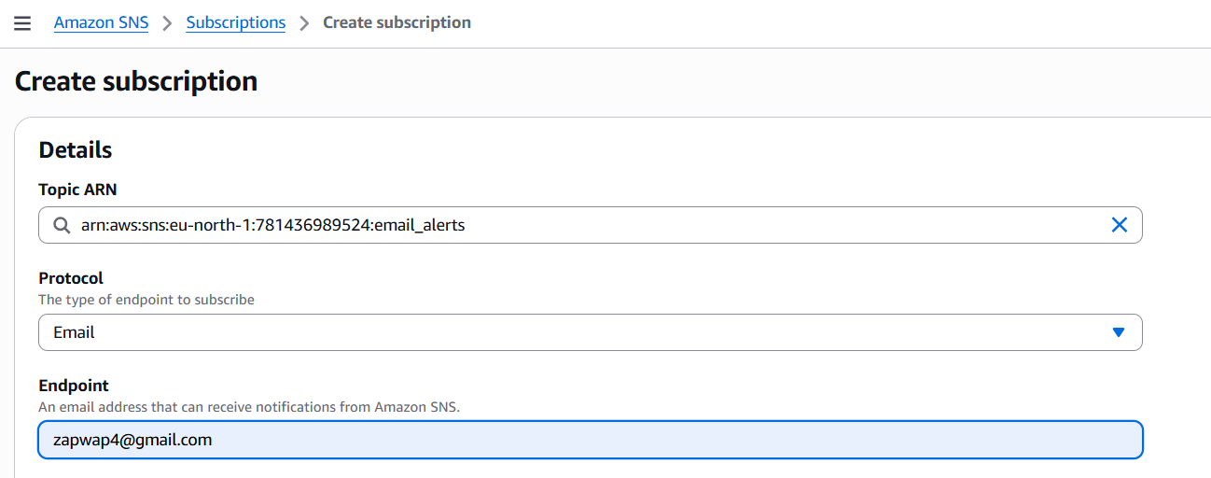
You will be receiving the email in the given email and you need to confirm on that
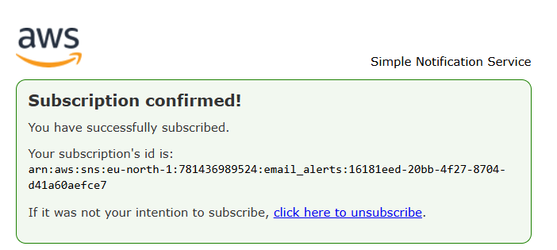
And attach the SNS in the cloud trail
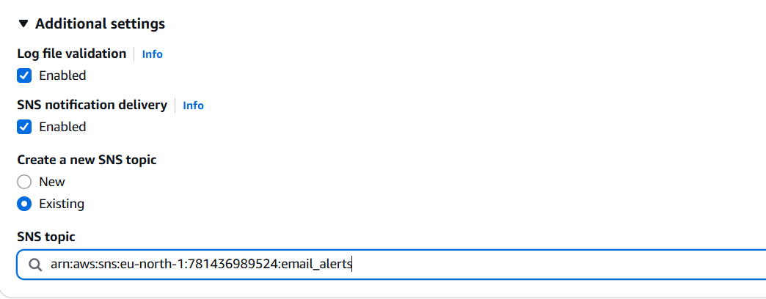
You can see that in the email

3. Configure CloudWatch monitoring and record the CPU utilization and other metrics of EC2
To monitor your EC2 instance's CPU utilization and other performance metrics using Amazon CloudWatch
First you need to create an instance, with enabling this below option in advanced details
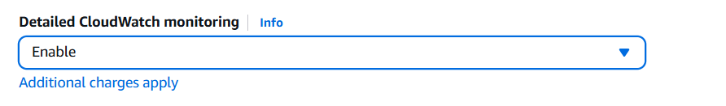
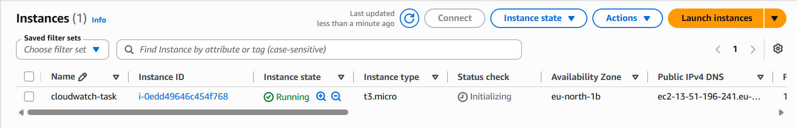
After that you can create a new dashboard with number
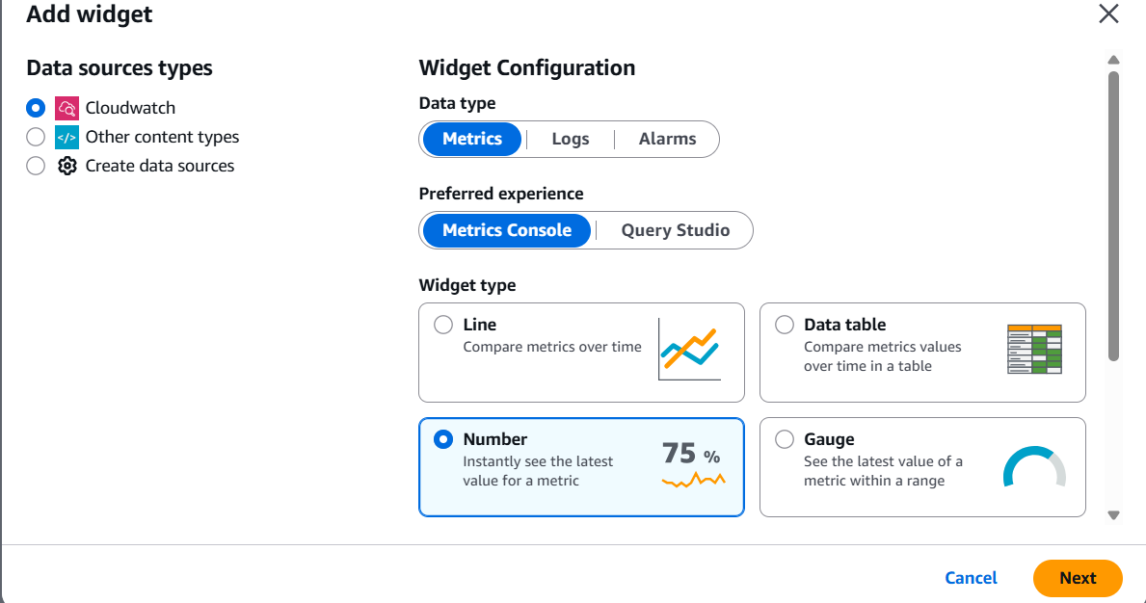
And in the customize settings, you can give it as 5
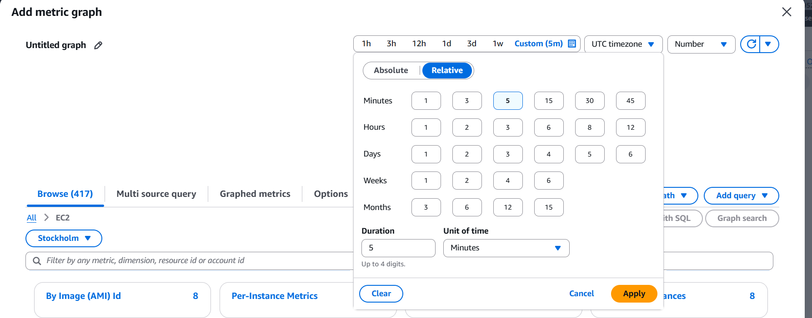
Below paste your instance ID and it shows the metrics, In that you can give CPU utilization
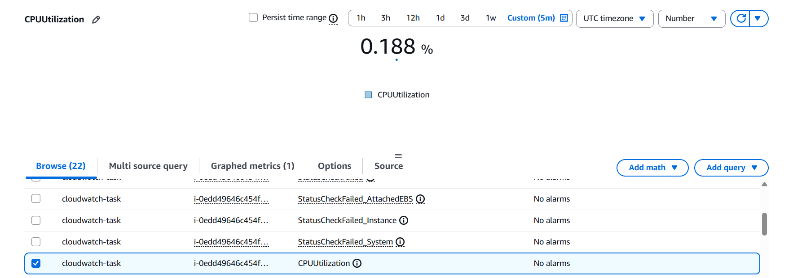
And add the widget and save
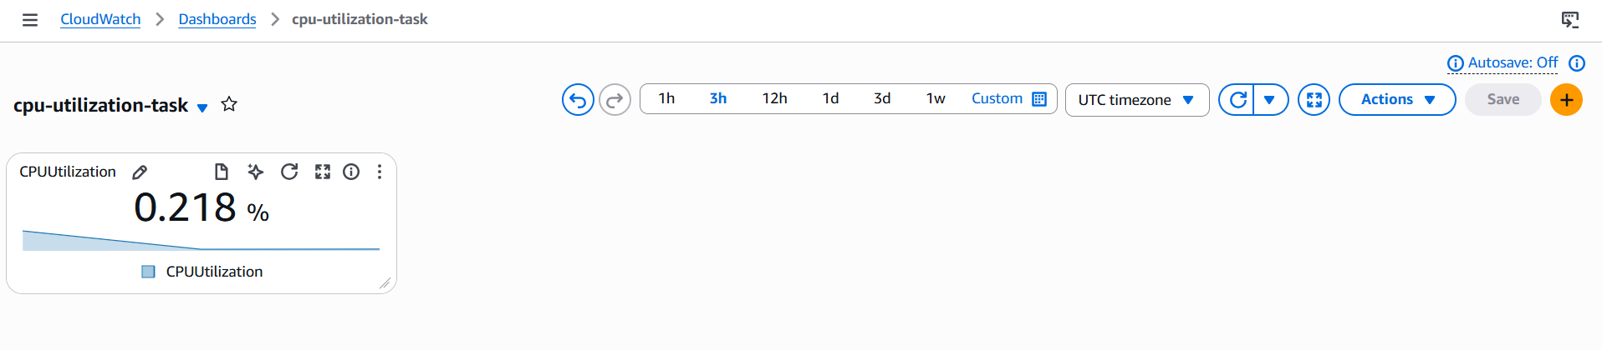

4. Create one alarm to send an alert to email if the CPU utilization is more than 70 percent
To trigger an email alert when an EC2 instance exceeds 70% CPU utilization, you need to combine two AWS services: Amazon CloudWatch to monitor the metric and trigger the alarm and SNS to send the actual email

Follow the same process in 3 rd task
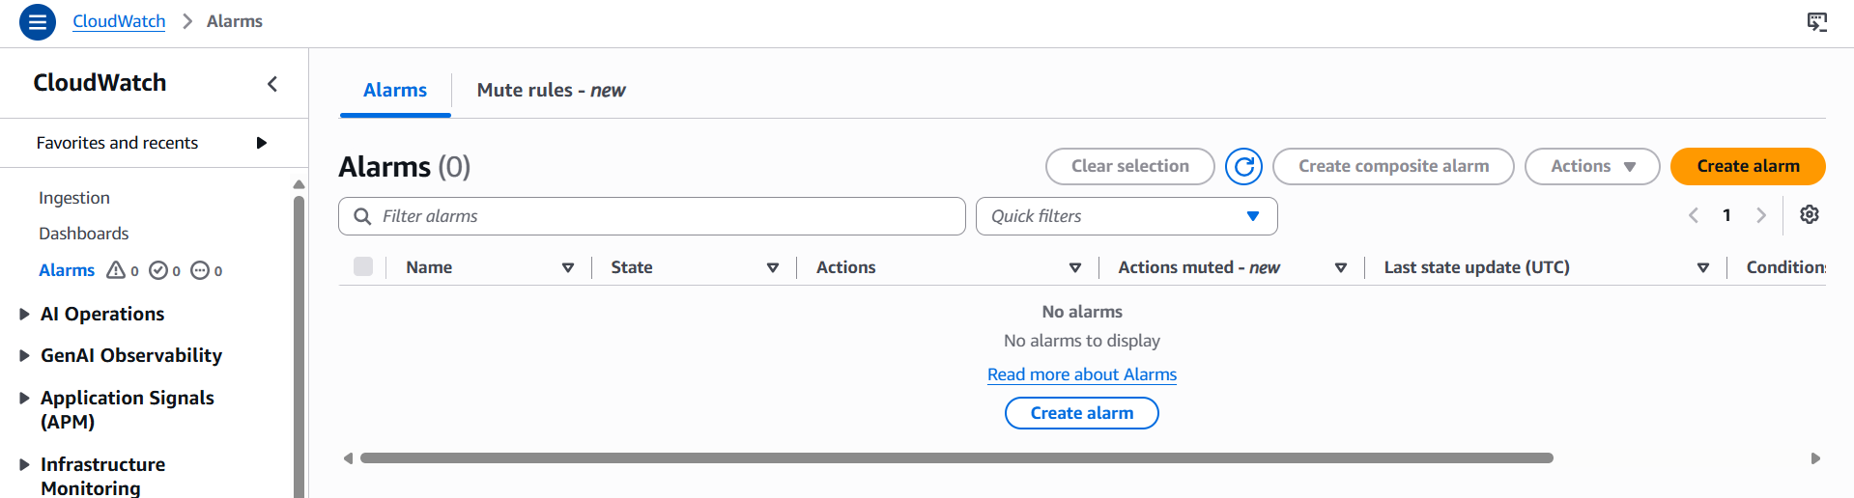
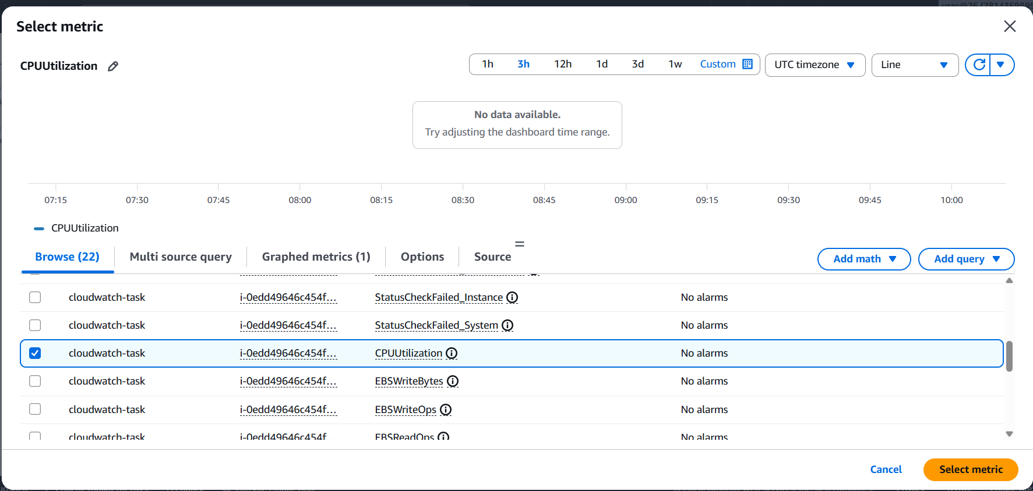
And here you can configure the cloudwatch
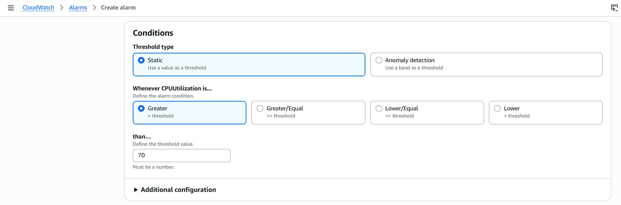
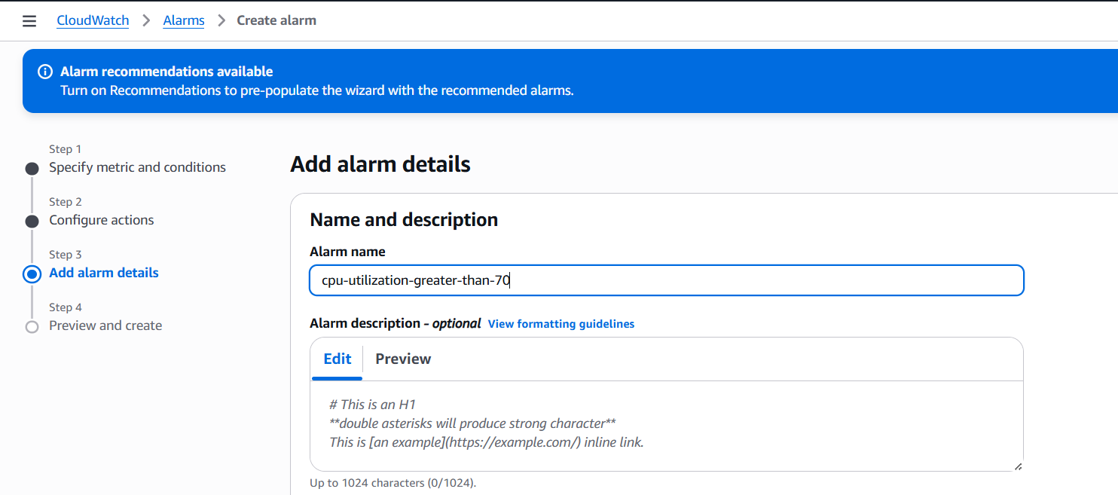
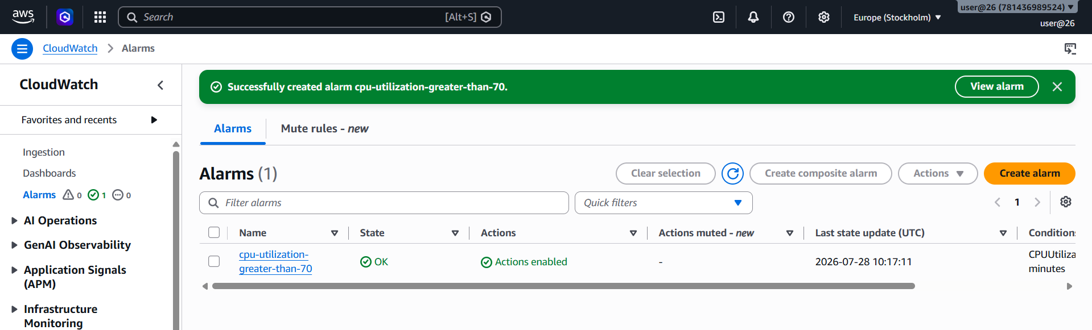
And then you can see the Alarm has been created

5. Create a Dashboard and monitor the Tomcat service whether it is running or not and send the alert
For installing tomcat, first we need to install java
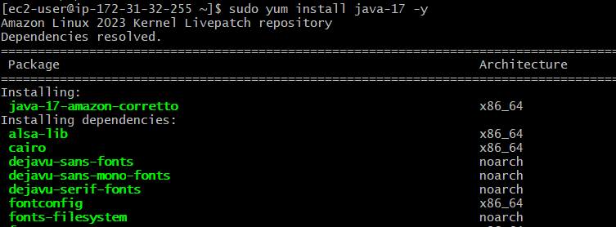
Download the tomcat using wget < >
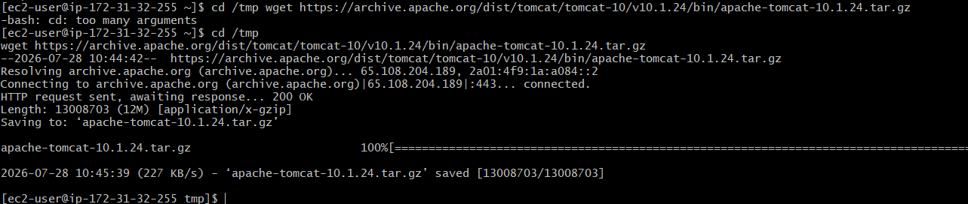
Start the tomcat using ./startup.sh and check for the status
And then create a bash script
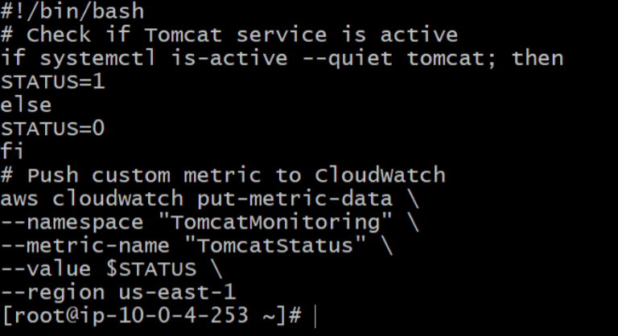
Give the permission as chmod 777 monitoring.sh
Create a IAM role CloudWatchFullAccess or CloudWatchAgentServerPolicy for that instance in the Action > Security > IAM role
And then go to cloudwatch and create a dashboard, in that if you see the tomcat click and create a widget and you can see it is running
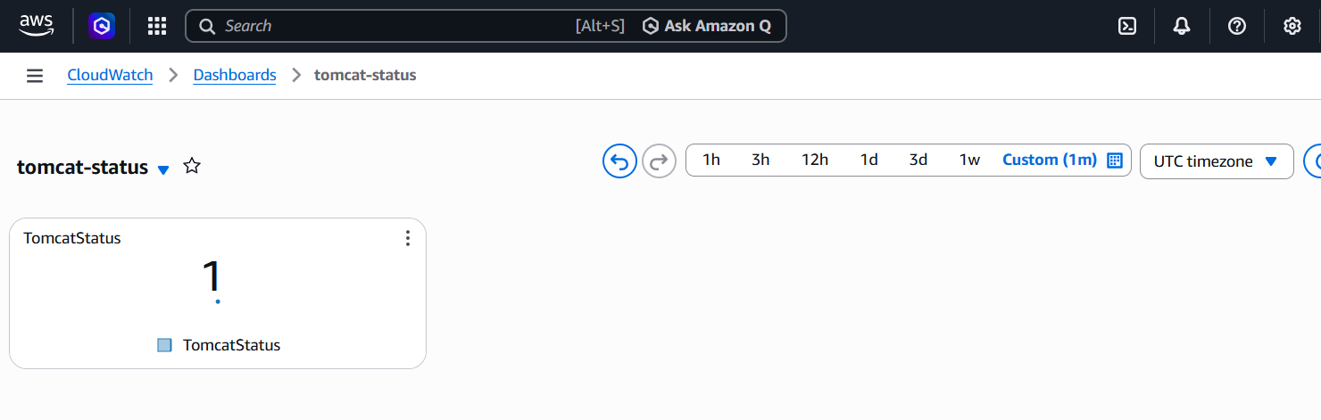

6. Create a Dashboard and monitor the Nginx service to send the alert if Nginx is not running
Here, install the nginx using sudo yum install nginx -y
And then start the services using sudo systemctl start nginx
And check it using sudo systemctl status nginx
And then create a new bash script file and give this script
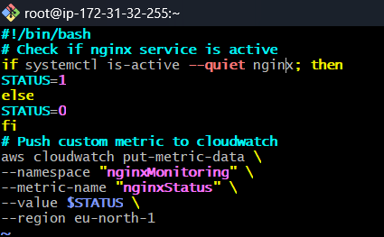
Give the permission, chmod 777 nginx.sh
And run the script using bash nginx.sh
Go to cloud watch and create a dashboard, make sure the region which u gave from bash script and the cloudwatch metric should be same
Check nginx on the same regions metrics, it is shown and you can create a widget on that
And then it shows the status as 1 or 0 according to the status

